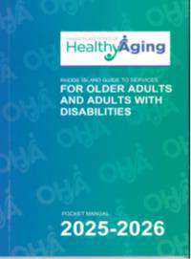
OHA Pocket Guide Order Form
Pocket Guide 2025-2026: Rhode Island Guide to Services for Older Adults and Adults with Disabilities
The Rhode Island Office of Healthy Aging (OHA) is thrilled to share the much-anticipated OHA resource, the “Pocket Guide 2025-2026: Rhode Island Guide to Services for Older Adults and Adults with Disabilities”.
This comprehensive guide is designed to equip older adults, adults with disabilities, and their families with the information and resources necessary to navigate the challenges and opportunities that come with aging.

Please fill out the order form with the required information and send it to Carol WeldonMartin, at Carol.Weldonmartin@oha.ri.gov
Organization: Contact person: Address: City: State: Zip: Phone:
Email:

Please note - supplies are limited. Re-orders may be processed as needed and online versions are available at:
Resources | Office of Healthy Aging.

Please specify English, Spanish, or Portuguese.
Service provider: (home care, day programs, nutrition providers, etc.) | 10-25 copies  ☐English ☐Spanish ☐Portuguese
Senior Centers & Municipal Offices | 1 case (96 booklets)  ☐English ☐Spanish ☐Portuguese
State & Business Partners | 10-25 Copies  ☐English ☐Spanish ☐Portuguese
Community Events | 1 case (96 booklets)  ☐English ☐Spanish ☐Portuguese

We hope that you will find this guide helpful and informative, and we encourage you to share it with your clients and colleagues. Thank you for your continued partnership in support of older adults, adults with disabilities and their families!

OHA PocketGuideOrderForm.9162024_CWM
Revised 12.2025

